PRODUCE STORAGE & PREPARATION GUIDE
From Farmer Ford Waterstrat at Sustainable Harvest farm
Produce Type | Image | Shelf Life  (with proper storage preparation) | Storage Preparation Tips
Bok Choy | 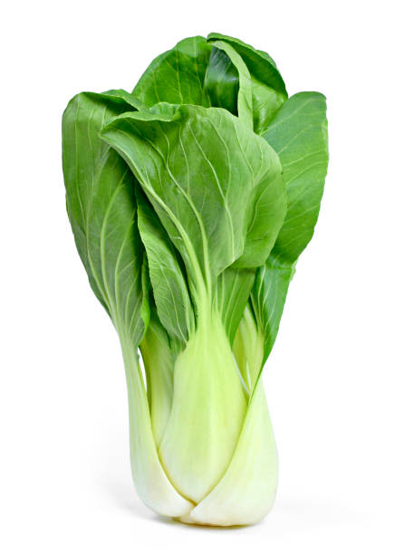 | 1 week | Wrap bok choy in a damp towel or place in plastic bag and store in the crisper drawer of the refrigerator
Broccoli | 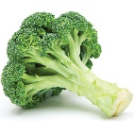 | 3-5 days | Short Term: Store in a plastic bag in the crisper drawer of refrigerator  Longer Term: Freeze by cutting into florets and slicing stems. Blanch for 3-4 minutes, rinse in cold water, drain, dry and place in airtight zip lock bag
Cabbage |  | 3 - 8 weeks | Refrigerate cabbage (in or without a plastic bag) in the crisper drawer of refrigerator. Do not remove outer leaves prior to storing.
Carrots | 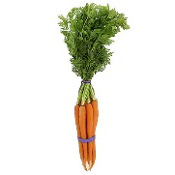 | 2 - 4 weeks | Short Term: Remove greens immediately and refrigerate carrots in a plastic bag.  Longer Term: Freeze by blanching for 3 minutes, rinse in cold water, drain, dry and place in airtight zip lock bag
Celery | 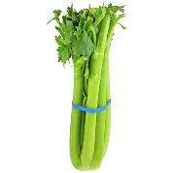 | 2 weeks | Short Term: Refrigerate as soon as possible to keep firmness. Place in a plastic bag and store in the crisper drawer.  Longer Term: Celery can be frozen by slicing and placing chunks on a baking tray in the freezer. When froze, place celery in an airtight container or zip lock bag.
Chard (Swiss) | 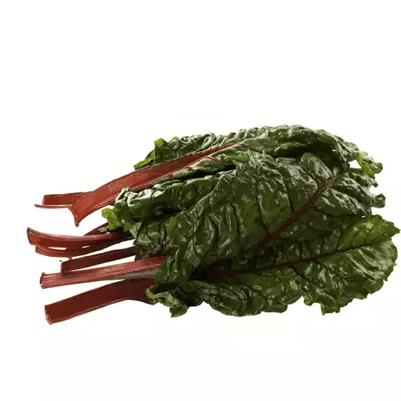 | 2-4 days | Short Term: Place in a plastic bag and store in the crisper drawer of refrigerator.  Longer Term: Chard freezes well. Blanch chopped leaves for 3 minutes, rinse with cold water, drain and lightly dry. Place in an airtight container or a zip lock bag.
Collard Greens | 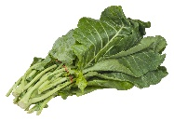 | 1 week | Short Term: Store unwashed in a plastic bag in the crisper drawer of your refrigerator. Keep moist.  Longer Term: Collard greens freeze well. Blanch washed greens for 2-3 minutes, rinse with cold water, drain and store in an airtight container or zip lock bag.
Corn | 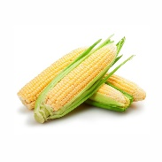 | ASAP | Short Term: Refrigerate immediately with husks on and use ASAP for maximum sweetness and flavor.  Longer Term: Corn freezes well. Blanch either on or off the cob for 3-5 minutes, rinse with cold water, drain, dry it fully, the store it in an airtight container or zip lock bag.
Cucumber | 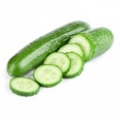 | 1 week | Refrigerate in the crisper drawer of your refrigerator. Cut or peeled cucumbers will spoil quickly.
Eggplant | 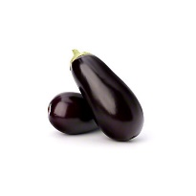 | 1 week | Store unrefrigerated at a cool room temperature or in the crisper drawer of refrigerator
Produce Type | Image | Shelf Life  (with proper storage preparation) | Storage Preparation Tips
Fennel | 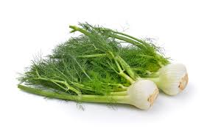 | 2 weeks | Store fennel in a plastic bag in the refrigerator.
Garlic | 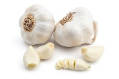 | Several months | Short Term: Store garlic in a cool, dark, dry and well-ventilated space. Warmer temps may cause garlic to sprout.  Longer Term: Mince and blend with olive oil and freeze in an airtight container.
Green Beans |  | 1 week | Short Term: Refrigerate in a plastic bag.  Longer Term: Beans freeze well. Blanch for 2-3 minutes, rinse in cold water, drain, dry thoroughly. And pack into airtight containers.
Kale | 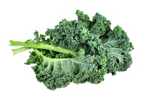 | 1 week | Short Term: Refrigerate in a plastic bag in the crisper drawer. Leaves will wilt if they dry out,  Longer Term: Kale can be frozen. Wash, remove the stem, and blanch leaves for 2 minutes. Rinse in cold water, drain and pack into airtight containers or zip lock bags.
Kohlrabi |  | 1 month | Store kohlrabi sphere and leaves separately. The sphere should be refrigerated in a plastic bag. The leaves should be placed in a plastic bag and stored in the crisper drawer.
Lettuce (Leaf) |  | Few days | Place lettuce in a plastic bag and store in refrigerator. To maintain freshness longer, place a paper towel in the plastic bag with the lettuce.
Onions | 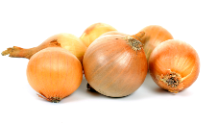 | Several months | Short Term: Store cut onions in the refrigerator in an airtight container. Use as soon as possible.  Longer Term: Store uncut onions in a cool, dry place to prevent sprouting from warmth and moisture.
Peppers | 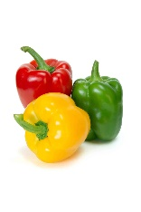 | 1-2 weeks | Short Term: Store peppers unwashed in the crisper drawer.  Longer Term: Peppers may be frozen by washing, drying and cutting them into small pieces. Store in an airtight container.
Potatoes | 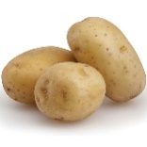 | Up to two weeks | Short Term: Store potatoes at room temperature and away from light.  Longer Term: Potatoes keep well at 45-degree temps, higher humidity and in darkness. Sprouting will occur if they are too warm.
Radishes | 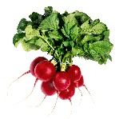 | 2 weeks | Store radishes in a plastic bag in the refrigerator. Store leafy tops separately wrapped in a damp towel in the crisper drawer.
Spinach | 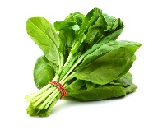 | 1 week | Short Term: Store in a plastic bag in the refrigerator.  Longer Term: Spinach may be frozen. Blanch for 1-2 minutes, rinse in cold water, drain and store in airtight container.
Summer Squash | 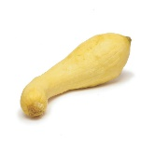 | 1 week | Short Term: Store in a plastic bag or the crisper drawer in the refrigerator.  Longer Term: Cooked or pureed squash can be frozen in an airtight container.
Produce Type | Image | Shelf Life  (with proper storage preparation) | Storage Preparation Tips
Sugar Snap Peas |  | 4-5 days | Short Term: Refrigerate in a plastic bag for 4-5 days max. Best used as soon as possible to enjoy their sweet flavor and crispness.  Longer Term: Peas can be frozen blanching for 2 mins., rinsing in cold water, draining and storing in airtight containers or zip lock bags.
Sweet Potatoes | 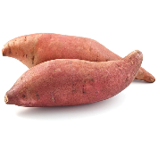 | Several weeks | Store sweet potatoes in a cool, dry place. Do not refrigerate and avoid excess moisture to prevent rotting and sprouting. Do not wash (scrub) until just before preparation.
Tomatoes | 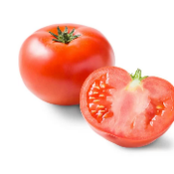 | 1 week | Store Term: Store tomatoes (out of the sun) at room temperature for up to one week or longer if still ripening. Do not refrigerate.  Longer Term: Whole tomatoes can be frozen by coring them and placing on a cookie sheet in the freezer. When froze solid, place in a zip lock bag and store in the freezer. Frozen tomatoes are good for cooking or purees.
Turnips | 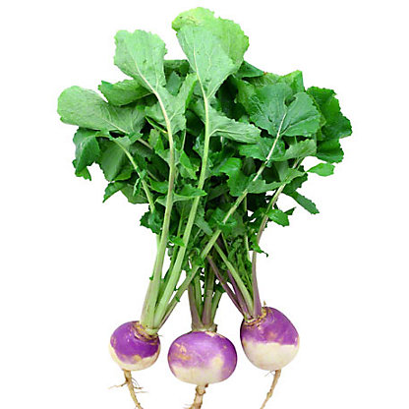 | 1-2 weeks | Short Term: Store turnips unwashed in a plastic bag. Store turnip greens separately wrapped in a damp towel or plastic bag in the crisper drawer of the refrigerator.  Longer Term: Turnips may be packed in moist sand and kept in a cool location.
Zucchini | 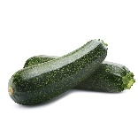 | 3-4 days | Short Term: Store in the crisper drawer of refrigerator.  Longer Term: Freeze zucchini puree or grated zucchini in an airtight container.
Fruits
Cantaloupe | 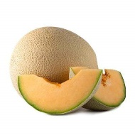 | 5-7 days | Short Term: A whole cantaloupe is best kept on the counter until ready to be cut open. Once ripe, it can be placed into the refrigerator. Longer Term: Cantaloupe can be sliced or balled and frozen in an airtight container.
Strawberries | 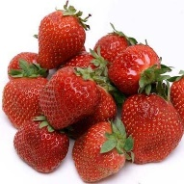 | 3-7 days | Short Term: Store freshly picked strawberries in a closed container in the refrigerator, and rinse gentle prior to use.  Longer Term: Strawberries can be frozen be washing, drying, hulling the leafy stem, and placing on a cookie sheet to freeze solid. Then, store in the freezer1 in a zip lock bag.
Watermelon | 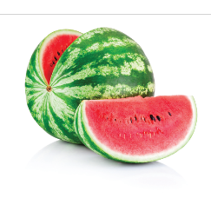 | 3 days (cut)  2-3 weeks (uncut) | Short Term: Store a cut watermelon by wrapping the cut side in plastic, and refrigerate.  Long Term: Once picked from the vine, watermelons will not ripen any further. Keep uncut watermelons in the refrigerator.

